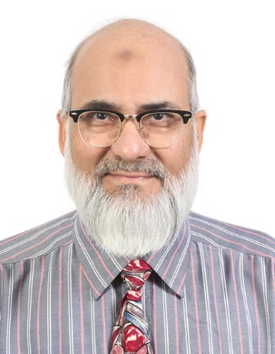
Dr. Muhammad Zafar is currently a Professor in Anatomy/Skill lab, and chairman of department of Clinical Skills at College of Medicine, Alfaisal University Riyadh Saudi Arabia. He has been a senior faculty member since September 2011 to date. He teaches different components of Anatomy to undergraduate and graduate students; He is a member of Curriculum committee since 2011.
Prior to his current assignment, Dr. Zafar worked as Professor of Anatomy at Faculty of Medicine, King Fahad Medical City Riyadh, Saudi Arabia for 4 years where he established a clinical skills Center. Dr. Zafar graduated with MBBS degree from Liaquat Medical College Jamshoro, Pakistan in 1989, and successfully completed his MPhil in Anatomy from Basic Medical Sciences Institute, Jinnah Postgraduate Medical Center Karachi, Pakistan in 1994. He continued his academic and professional accomplishments and completed his doctorate (Ph.D.) in Anatomy from Baqai Medical University, Karachi Pakistan in 2002-2003. Dr. Zafar continued his academic achievements and became the visiting Professor at College of Physicians and Surgeons, Pakistan and Inspector of Anatomy for Pakistan Medical & Dental Council, Islamabad.
His professional teaching and training experience spans over 35 years in various undergraduate & post graduate medical & Dental institutions and hospitals in Pakistan, as well as in Saudi Arabia. Dr. Zafar has attended numerous national & international medical Conferences & presented numerous oral and poster presentations and facilitated workshops in simulation. To his credit, Dr. Zafar has written several publications in International Journals.
Contact information:
Phone: 00966-11-2157687 (Office), 00966-561287496 (mobile)
Email: zafardoctor@hotmail.com
mzafar@alfaisal.edu

